Constructing Regular Pentagon

Definition
# Source: AI Source: Provided by: [Data Path: Persons Table -> ID Column: 1, Name_En Column: Motasem Essam] -> From: [ChatGPT] on [7/25/2026]
Constructing a Regular Pentagon is the geometric construction of a five-sided polygon in which all five sides are equal and all five interior angles are equal, using exact geometric methods, typically with a straightedge and compass.
For a regular pentagon $ABCDE$:
$$\boxed{AB=BC=CD=DE=EA}$$
and:
$$\boxed{∠A=∠B=∠C=∠D=∠E={108}^{∘}}$$
A regular pentagon has five equal central angles:
$$\boxed{{72}^{∘}}$$
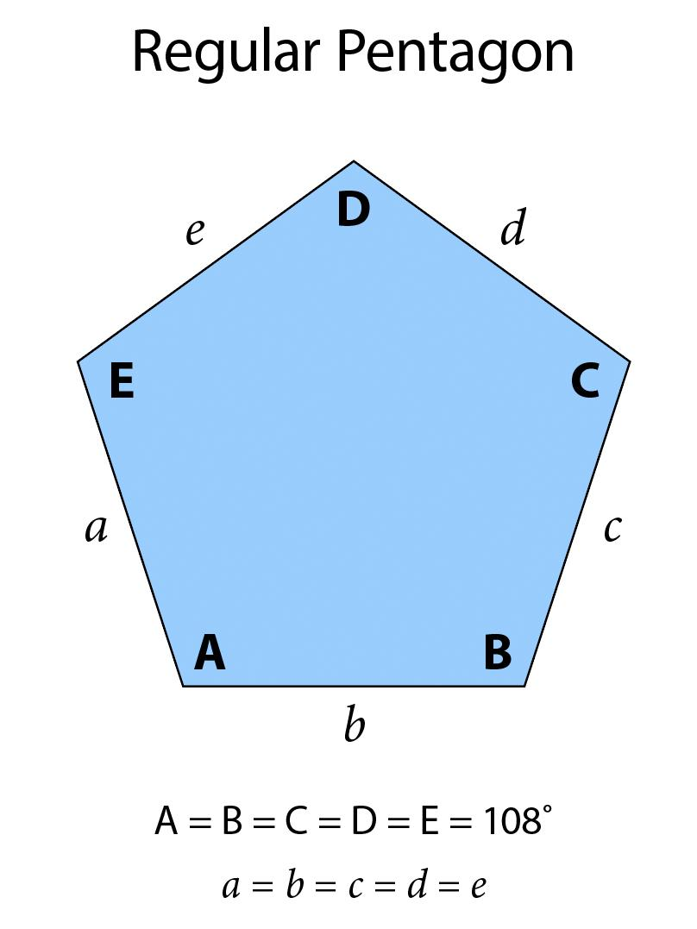
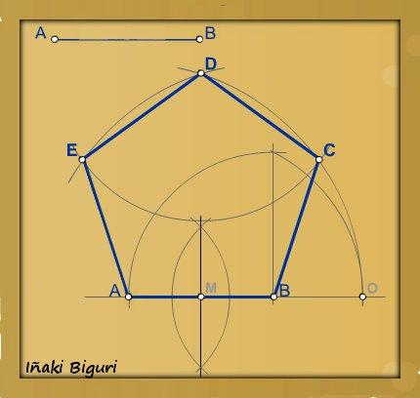
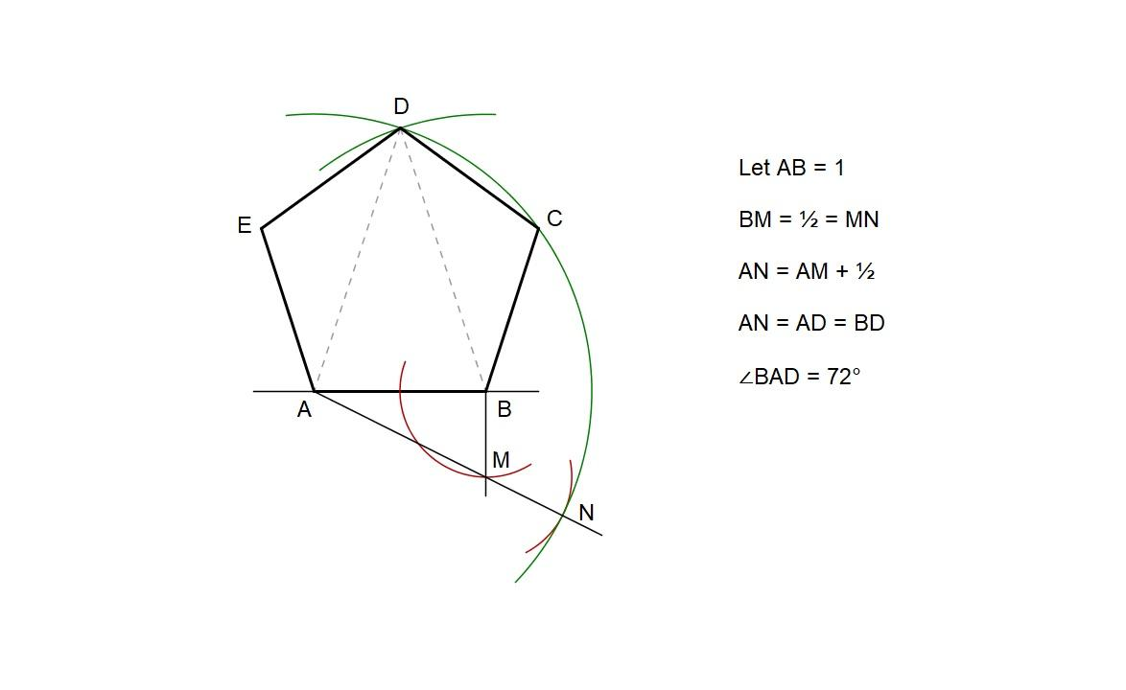
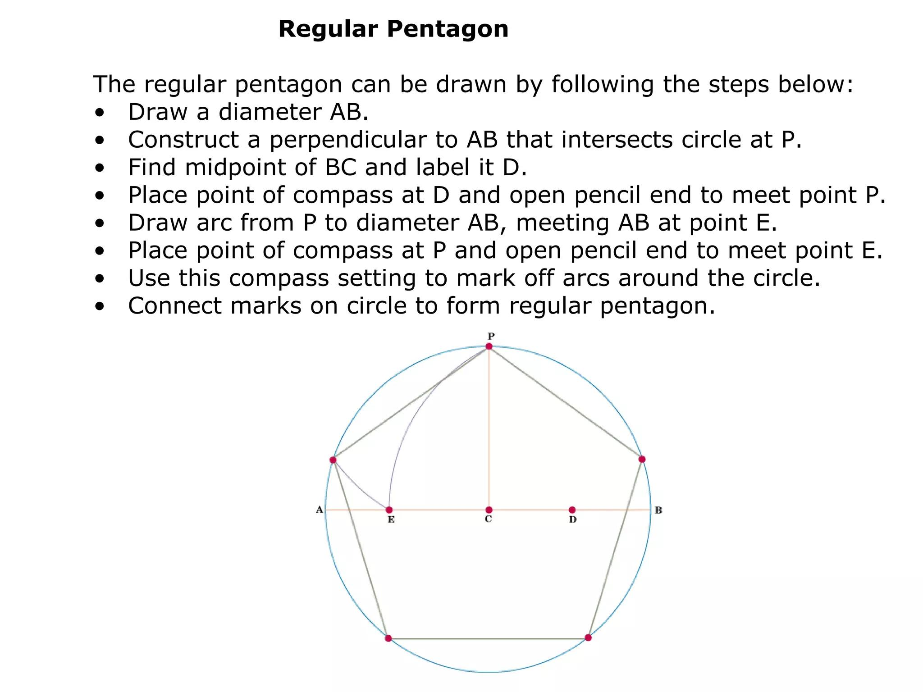

Fundamental Concept
# Source: AI Source: Provided by: [Data Path: Persons Table -> ID Column: 1, Name_En Column: Motasem Essam] -> From: [ChatGPT] on [7/25/2026]
A regular pentagon is a regular polygon with:
$$n=5$$
The sum of its interior angles is:
$$\left(5-2\right){180}^{∘}={540}^{∘}$$
Therefore, each interior angle is:
$$\frac{{540}^{∘}}{5}={108}^{∘}$$
Its central angle is:
$$\frac{{360}^{∘}}{5}={72}^{∘}$$
Thus, a regular pentagon can be constructed by creating five equal central angles or five equal chords of a circumcircle.

Main Construction – From a Circumcircle
# Source: AI Source: Provided by: [Data Path: Persons Table -> ID Column: 1, Name_En Column: Motasem Essam] -> From: [ChatGPT] on [7/25/2026]
One classical straightedge-and-compass method constructs a regular pentagon inside a given circle.
Let the circle have center $O$and radius $R$.
Construction Steps
- Construct a circle with center $O$.
- Draw a diameter $AC$.
- Construct a perpendicular diameter through $O$.
- Let $B$be the upper intersection of this diameter with the circle.
- Bisect the radius $OC$, locating its midpoint $M$.
- Draw segment $BM$.
- Use the appropriate length obtained from this construction as the side of the regular pentagon.
- Transfer this length around the circumference five times.
- Mark the five vertices.
- Connect consecutive vertices.
The resulting polygon is a regular pentagon.

Construction Using a Given Side
# Source: AI Source: Provided by: [Data Path: Persons Table -> ID Column: 1, Name_En Column: Motasem Essam] -> From: [ChatGPT] on [7/25/2026]
If the side length $s$is given, construct one side first and then determine the remaining vertices.
The circumradius is:
$$\boxed{R=\frac{s}{2\sin{{36}^{∘}}}}$$
The apothem is:
$$\boxed{a=\frac{s}{2\tan{{36}^{∘}}}}$$
After constructing the circumcircle, the remaining vertices can be located by transferring the side length around the circle.

Construction Using the Diagonal
# Source: AI Source: Provided by: [Data Path: Persons Table -> ID Column: 1, Name_En Column: Motasem Essam] -> From: [ChatGPT] on [7/25/2026]
A regular pentagon has an important relationship between its side and diagonal.
Let:
$$d=AC$$
be a diagonal and:
$$s=AB$$
be a side.
For a regular pentagon:
$$\boxed{\frac{d}{s}=φ}$$
where:
$$\boxed{φ=\frac{1+\sqrt{5}}{2}}$$
Therefore:
$$\boxed{d=φs}$$
and:
$$\boxed{s=\frac{d}{φ}}$$
This relationship allows a regular pentagon to be constructed when its diagonal is given.
Construction From a Given Diagonal
Suppose the diagonal $AC=d$is given.
- Construct the diagonal:
$$\overset{‾}{AC}$$
- Construct the perpendicular bisector of $AC$.
- Let $O$be the midpoint of $AC$.
- Construct the appropriate circumradius using the diagonal and the golden-ratio relationship.
- Construct the circumcircle centered at $O$.
- Use the relationship:
$$\boxed{s=\frac{d}{φ}}$$
to determine the pentagon's side length.
- Transfer the side length around the circumcircle.
- Mark the remaining vertices.
- Connect the five vertices.
The resulting pentagon has:
$$AB=BC=CD=DE=EA=s$$
and diagonal:
$$AC=d$$
Classical Diagonal Construction
The diagonal can also be used directly to establish the golden-ratio division associated with the pentagon.
For a regular pentagon:
$$\boxed{\frac{\text{Diagonal}}{\text{Side}}=φ}$$
Therefore, the diagonal and side are related by the golden ratio.
This is one of the important reasons the regular pentagon has a particularly useful straightedge-and-compass construction.

Construction Using Central Angles
# Source: AI Source: Provided by: [Data Path: Persons Table -> ID Column: 1, Name_En Column: Motasem Essam] -> From: [ChatGPT] on [7/25/2026]
For a regular pentagon:
$$θ=\frac{{360}^{∘}}{5}={72}^{∘}$$
Therefore:
- Construct a circle.
- Mark a starting point $A$.
- Construct a ${72}^{∘}$central angle.
- Mark $B$.
- Repeat the same ${72}^{∘}$angle around the center.
- Obtain:
$$A,B,C,D,E$$
- Connect consecutive vertices.
Thus:
$$∠AOB=∠BOC=∠COD=∠DOE=∠EOA={72}^{∘}$$

Mathematical Properties
# Source: AI Source: Provided by: [Data Path: Persons Table -> ID Column: 1, Name_En Column: Motasem Essam] -> From: [ChatGPT] on [7/25/2026]
Number of Sides
$$\boxed{n=5}$$
Interior Angle
$$\boxed{{108}^{∘}}$$
Exterior Angle
$$\boxed{{72}^{∘}}$$
Central Angle
$$\boxed{{72}^{∘}}$$
Equal Sides
$$\boxed{AB=BC=CD=DE=EA}$$
Perimeter
If each side has length $s$:
$$\boxed{P=5s}$$
Area
Using the side length:
$$\boxed{A=\frac{1}{4}\sqrt{5\left(5+2\sqrt{5}\right)} s^{2}}$$
Using the apothem $a$:
$$\boxed{A=\frac{1}{2}Pa}$$
or:
$$\boxed{A=\frac{5}{2}sa}$$
Diagonal
If the side length is $s$:
$$\boxed{d=\frac{1+\sqrt{5}}{2}s}$$
Therefore:
$$\boxed{d=φs}$$
where:
$$\boxed{φ=\frac{1+\sqrt{5}}{2}}$$
Symmetry
A regular pentagon has:
- 5 lines of reflection symmetry
- 5-fold rotational symmetry
Its fundamental rotational symmetry angle is:
$$\boxed{{72}^{∘}}$$
Rotations of:
$${72}^{∘}, {144}^{∘}, {216}^{∘}, {288}^{∘}, {360}^{∘}$$
map the pentagon onto itself.

Construction Situations
# Source: AI Source: Provided by: [Data Path: Persons Table -> ID Column: 1, Name_En Column: Motasem Essam] -> From: [ChatGPT] on [7/25/2026]
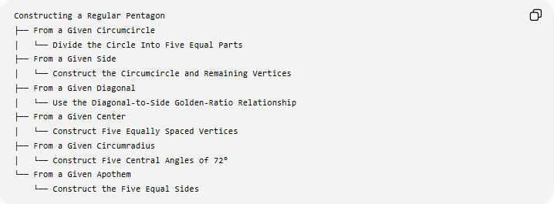
Constructing a Regular Pentagon
├── From a Given Circumcircle
│ └── Divide the Circle Into Five Equal Parts
├── From a Given Side
│ └── Construct the Circumcircle and Remaining Vertices
├── From a Given Diagonal
│ └── Use the Diagonal-to-Side Golden-Ratio Relationship
├── From a Given Center
│ └── Construct Five Equally Spaced Vertices
├── From a Given Circumradius
│ └── Construct Five Central Angles of 72°
└── From a Given Apothem
└── Construct the Five Equal Sides
These are construction situations based on the given information, rather than different mathematical types of regular pentagons.

Basic Constructions Used
# Source: AI Source: Provided by: [Data Path: Persons Table -> ID Column: 1, Name_En Column: Motasem Essam] -> From: [ChatGPT] on [7/25/2026]
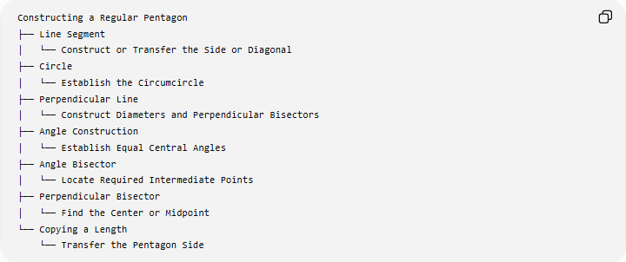
Constructing a Regular Pentagon
├── Line Segment
│ └── Construct or Transfer the Side or Diagonal
├── Circle
│ └── Establish the Circumcircle
├── Perpendicular Line
│ └── Construct Diameters and Perpendicular Bisectors
├── Angle Construction
│ └── Establish Equal Central Angles
├── Angle Bisector
│ └── Locate Required Intermediate Points
├── Perpendicular Bisector
│ └── Find the Center or Midpoint
└── Copying a Length
└── Transfer the Pentagon Side

Regular Pentagon and Its Diagonal
# Source: AI Source: Provided by: [Data Path: Persons Table -> ID Column: 1, Name_En Column: Motasem Essam] -> From: [ChatGPT] on [7/25/2026]
The diagonal is particularly important because the five diagonals of a regular pentagon form a pentagram when extended and connected appropriately.
For a regular pentagon:
$$\boxed{\frac{d}{s}=φ}$$
This gives the relationship:
$$\boxed{d:s=φ:1}$$
and:
$$\boxed{s:d=1:φ}$$
Thus, knowing either the side or diagonal determines the other.

Regular Pentagon and Circle
# Source: AI Source: Provided by: [Data Path: Persons Table -> ID Column: 1, Name_En Column: Motasem Essam] -> From: [ChatGPT] on [7/25/2026]
A regular pentagon can always be inscribed in a circle.
The circle is its circumcircle, and its center is the circumcenter.
For vertices $A,B,C,D,E$:
$$OA=OB=OC=OD=OE=R$$
and:
$$∠AOB=∠BOC=∠COD=∠DOE=∠EOA={72}^{∘}$$
Therefore:
$$\boxed{\text{Regular Pentagon}=\text{Five Equal Chords of a Circle}}$$

Regular Pentagon vs Irregular Pentagon
# Source: AI Source: Provided by: [Data Path: Persons Table -> ID Column: 1, Name_En Column: Motasem Essam] -> From: [ChatGPT] on [7/25/2026]
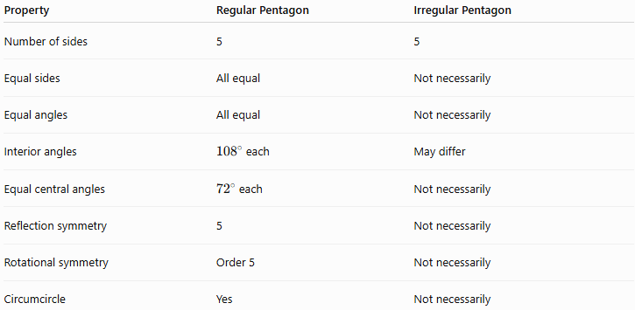
Property | Regular Pentagon | Irregular Pentagon
Number of sides | 5 | 5
Equal sides | All equal | Not necessarily
Equal angles | All equal | Not necessarily
Interior angles | ${108}^{∘}$each | May differ
Equal central angles | ${72}^{∘}$each | Not necessarily
Reflection symmetry | 5 | Not necessarily
Rotational symmetry | Order 5 | Not necessarily
Circumcircle | Yes | Not necessarily

Regular Pentagon vs Other Regular Polygons
# Source: AI Source: Provided by: [Data Path: Persons Table -> ID Column: 1, Name_En Column: Motasem Essam] -> From: [ChatGPT] on [7/25/2026]
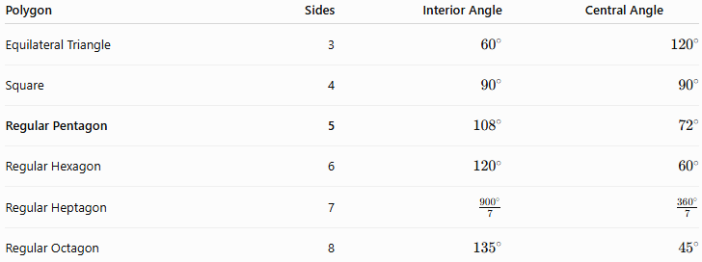
Polygon | Sides | Interior Angle | Central Angle
Equilateral Triangle | 3 | $${60}^{∘}$$ | $${120}^{∘}$$
Square | 4 | $${90}^{∘}$$ | $${90}^{∘}$$
Regular Pentagon | 5 | $${108}^{∘}$$ | $${72}^{∘}$$
Regular Hexagon | 6 | $${120}^{∘}$$ | $${60}^{∘}$$
Regular Heptagon | 7 | $$\frac{{900}^{∘}}{7}$$ | $$\frac{{360}^{∘}}{7}$$
Regular Octagon | 8 | $${135}^{∘}$$ | $${45}^{∘}$$

Classification
# Source: AI Source: Provided by: [Data Path: Persons Table -> ID Column: 1, Name_En Column: Motasem Essam] -> From: [ChatGPT] on [7/25/2026]
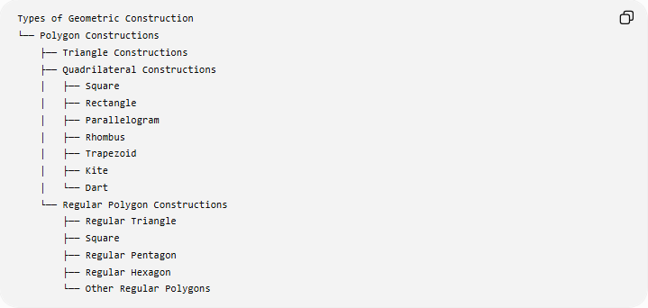
Types of Geometric Construction
└── Polygon Constructions
├── Triangle Constructions
├── Quadrilateral Constructions
│ ├── Square
│ ├── Rectangle
│ ├── Parallelogram
│ ├── Rhombus
│ ├── Trapezoid
│ ├── Kite
│ └── Dart
└── Regular Polygon Constructions
├── Regular Triangle
├── Square
├── Regular Pentagon
├── Regular Hexagon
└── Other Regular Polygons
Detailed Classification
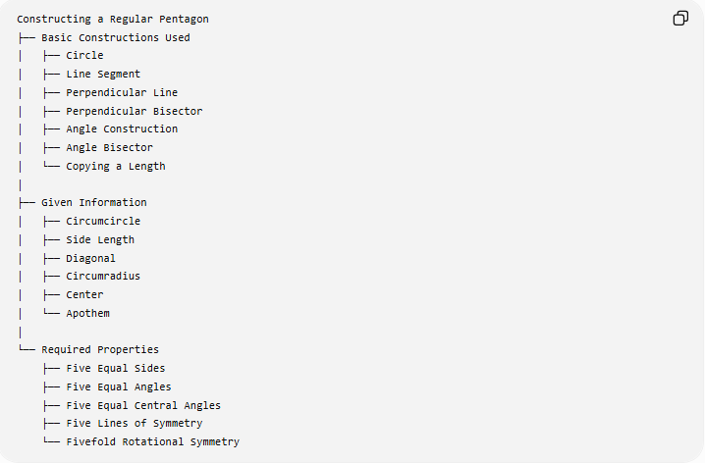
Constructing a Regular Pentagon
├── Basic Constructions Used
│ ├── Circle
│ ├── Line Segment
│ ├── Perpendicular Line
│ ├── Perpendicular Bisector
│ ├── Angle Construction
│ ├── Angle Bisector
│ └── Copying a Length
│
├── Given Information
│ ├── Circumcircle
│ ├── Side Length
│ ├── Diagonal
│ ├── Circumradius
│ ├── Center
│ └── Apothem
│
└── Required Properties
├── Five Equal Sides
├── Five Equal Angles
├── Five Equal Central Angles
├── Five Lines of Symmetry
└── Fivefold Rotational Symmetry

Key Points
# Source: AI Source: Provided by: [Data Path: Persons Table -> ID Column: 1, Name_En Column: Motasem Essam] -> From: [ChatGPT] on [7/25/2026]
- A regular pentagon has exactly 5 equal sides.
- It has 5 equal interior angles:
$${108}^{∘}$$
- Its central and exterior angles are:
$${72}^{∘}$$
- It can be constructed exactly using a straightedge and compass.
- A circumcircle can be divided into five equal arcs to construct the pentagon.
- A regular pentagon can also be constructed using its diagonal.
- Its diagonal and side satisfy:
$$\boxed{\frac{d}{s}=φ}$$
- The golden ratio is:
$$\boxed{φ=\frac{1+\sqrt{5}}{2}}$$
- It has 5 lines of reflection symmetry.
- It has rotational symmetry of order 5.
- Its five diagonals can form a pentagram.

Conclusion
# Source: AI Source: Provided by: [Data Path: Persons Table -> ID Column: 1, Name_En Column: Motasem Essam] -> From: [ChatGPT] on [7/25/2026]
Constructing a Regular Pentagon is the exact geometric construction of a five-sided regular polygon using straightedge-and-compass techniques. It can be constructed from a circumcircle, side, diagonal, center, circumradius, or apothem. The diagonal provides a particularly important construction relationship because the ratio of the diagonal to the side is the golden ratio:
$$\boxed{\frac{\text{Diagonal}}{\text{Side}}=\frac{1+\sqrt{5}}{2}}$$
Thus, the regular pentagon connects fundamental geometric constructions—circles, perpendicular bisectors, angles, equal chords, and length transfer—with the golden ratio.

